
Jolly Helmet
Make your Helmet Happy Again!
Clean it. Dry it.
Wear it happy.
Coin-operated helmet cleaning and drying stations
MEJES, JERAHMEEL ALZEL M.
CRUZ, DEAN RYAN P.
MENDOZA, RICAH S.
MARTOS, KRISTINA E.
DEVELOPERS AND DESIGNERS
USER MANUAL

Contents
Customer guide 2
Meet the machines 2
Before you start 2
Box 1 - Cleaner 4
Box 2 - Dryer 7
Box 3 - Cleaner + Dryer 8
Prices and time 10
Special screens and safety 11
Admin guide (Control Center) 13
Connecting 14
Home page 14
Box settings (rules, levels, phases) 15
Screen refresh and maintenance 18
Refill station (ACS) 20
Troubleshooting and care 22
Technician guide (Hardware and maintenance) 23
How it is built 24
Component list 26
Pinouts 28
Circuit and wiring 32
Firmware and flashing 37
Maintenance 39
Hardware troubleshooting 41

Customer guide

Welcome to Jolly Helmet!
A self-service station that cleans and dries your motorcycle helmet while you wait.

Meet the machines
There are three Jolly Helmet stations. Each one has a touch screen, a coin slot and a door. Pick the one that fits what your helmet needs.

Photo: Box 1 | Photo: Box 2 | Photo: Box 3

Station | What it does
Box 1  Cleaner | Removes odor. UV light plus a fine mist of alcohol, scented liquid, or both.
Box 2  Dryer | Dries a wet helmet with warm air, then cools it down before you take it out.
Box 3  Cleaner + Dryer | One station, two modes. Choose CLEANING or DRYING on the first screen.

Tip / Paalala: Pwede mong gamitin ang Box 1 at Box 2 nang magkasunod: linis muna, tapos tuyo.

Before you start
You need: your helmet and coins. The machine counts coins by value: a one-peso coin counts as 1.

How the touch screen works
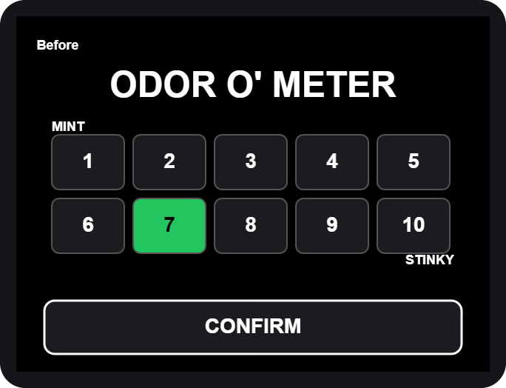  Rating grid: tap a box 1-10, then CONFIRM | 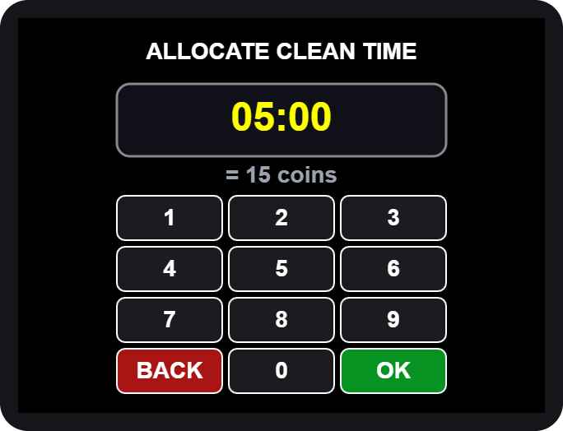  Number pad: type the minutes and seconds, then OK

- Big words (yellow) tell you what to do next: OPEN, PLACE, CLOSE, TAKE.
- Buttons are the dark boxes with white words. Tap them once.
- The screen blinks briefly now and then. This is normal, it refreshes itself.

Never put your hand in while the machine runs. If you open the door, the machine pauses by itself.

Box 1 - Cleaner
  1. Tap anywhere to START |   2. Welcome

- Wake the machine. Tap anywhere on the screen. For a moment it says "Please Wait" while it checks its alcohol and scented liquid.
- Tap to START on the welcome screen.

If the screen says OUT OF ORDER, the station needs refilling or service. Please tell the staff.

Rate it and choose the mist
3. ODOR O' METER | 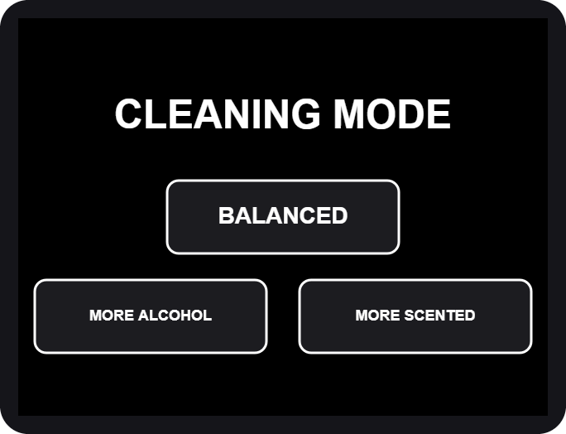  4. CLEANING MODE

- Rate the smell. Tap 1 (MINT, fresh) to 10 (STINKY), then CONFIRM. The worse the smell, the more time we suggest.
- Choose the mist. BALANCED uses both liquids, MORE ALCOHOL is stronger against germs, MORE SCENTED leaves a fresher scent.

Pick the time and pay
5. ALLOCATE CLEAN TIME | 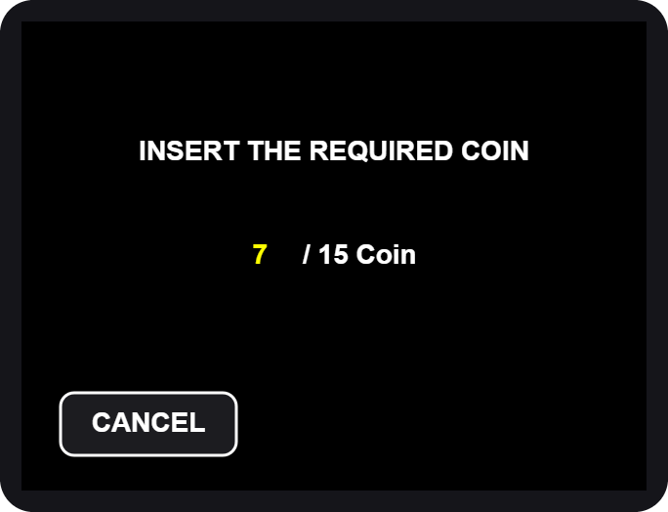  6. INSERT THE REQUIRED COIN

- Allocate time. The pad shows the time we suggest for your rating. Type a different time if you like, then tap OK. The shortest time and the longest time are shown if you go outside them.
- Insert the coins. The screen counts up: coins inserted / coins required. When it is enough, the machine moves on by itself.

Extra coins beyond the price give no extra time and are not refunded. Tap CANCEL before paying if you change your mind.

Load your helmet
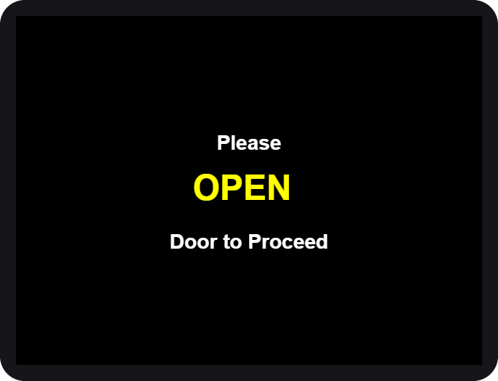  7. OPEN | 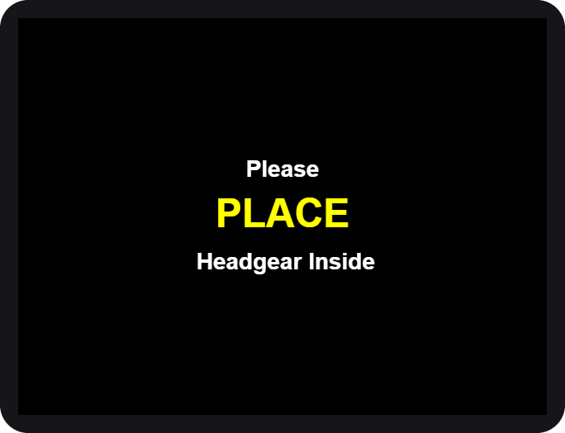  8. PLACE | 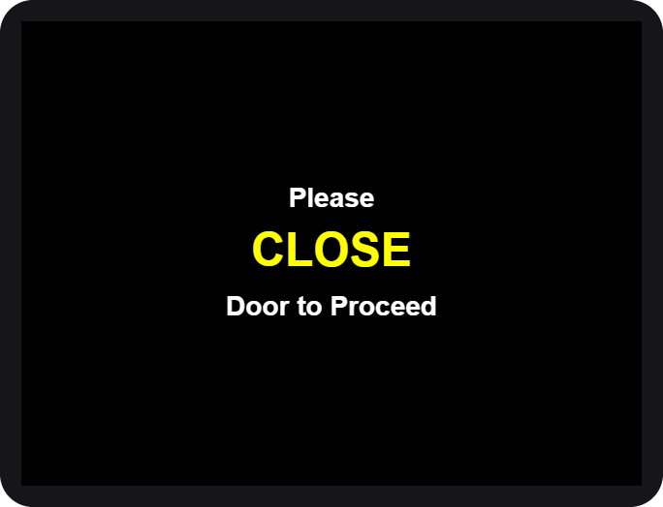  9. CLOSE

- OPEN the door when the screen asks.
- PLACE your helmet inside, opening facing the front, then step back.
- CLOSE the door. The machine checks that the door is shut and the helmet is inside, then starts.

If you see HELMET NO DETECTED, the machine did not see your helmet. Open the door and place it again.

While it cleans
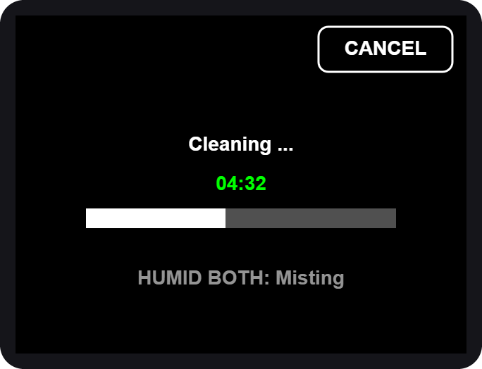  10. Cleaning... time left | 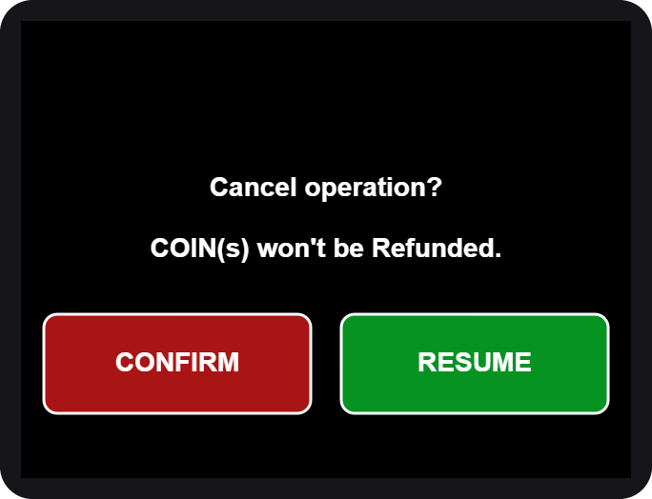  CANCEL asks first

- The big green number is the time left. The bar fills as it goes.
- The small grey line shows what is on: the mist, the UV light.
- To stop early tap CANCEL, then CONFIRM. Coins are not refunded. RESUME keeps cleaning.

If the door is opened during a run, everything pauses (SAFETY PAUSE). Close the door and it continues where it stopped.

All done
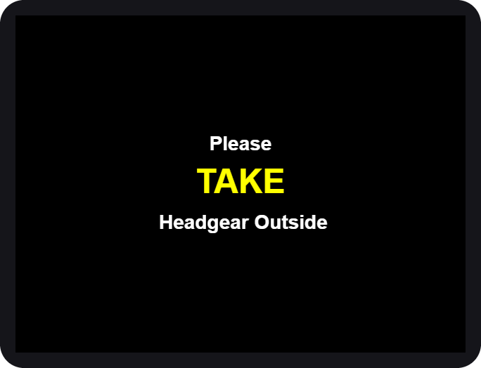  11. TAKE your helmet | 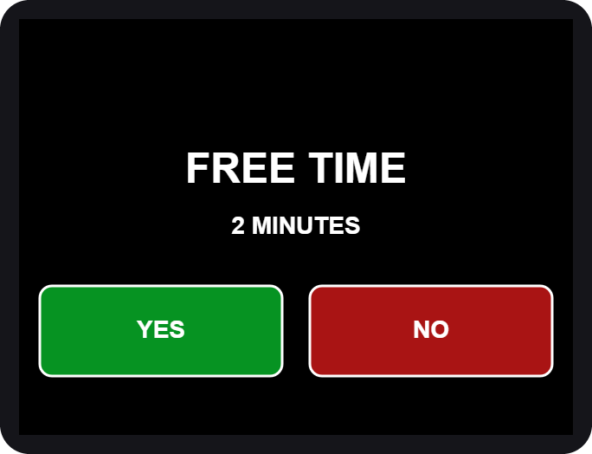  13. FREE TIME?

- OPEN the door and TAKE your helmet. Close the door again.
- Rate it again on the same 1-10 grid, then CONFIRM.
- Free retry. Not happy yet? The machine may offer a short FREE TIME (2 minutes). Tap YES to run once more, or NO. It is offered once per visit.
- The screen thanks you and returns to the start.

Box 2 - Dryer
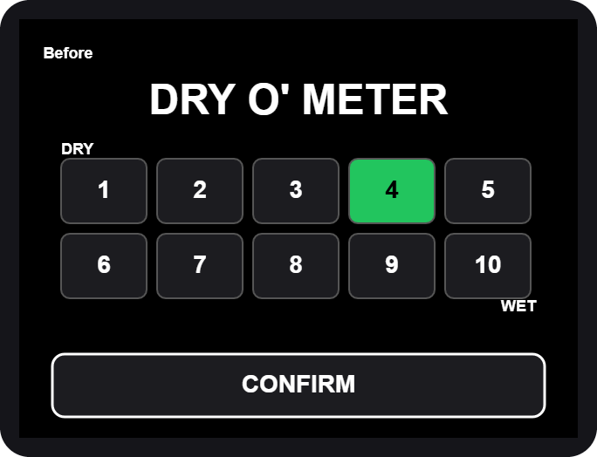  DRY O' METER | 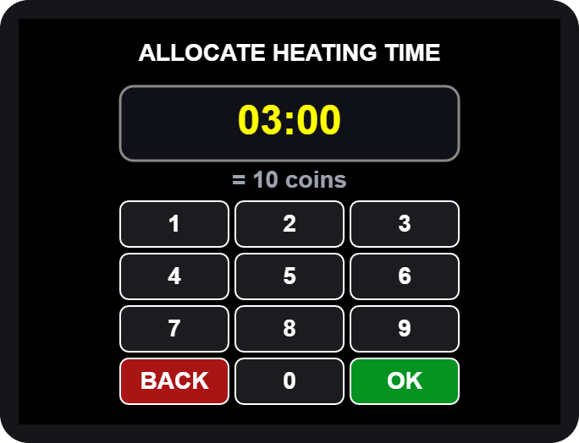  ALLOCATE HEATING TIME

- Tap anywhere, then Tap to START (same as Box 1).
- Rate how wet it is: 1 = DRY ... 10 = WET, then CONFIRM.
- Allocate heating time on the number pad, then OK.
- Insert the coins shown on the screen.
- OPEN, PLACE, CLOSE the door, same as Box 1.

Heating and cooling
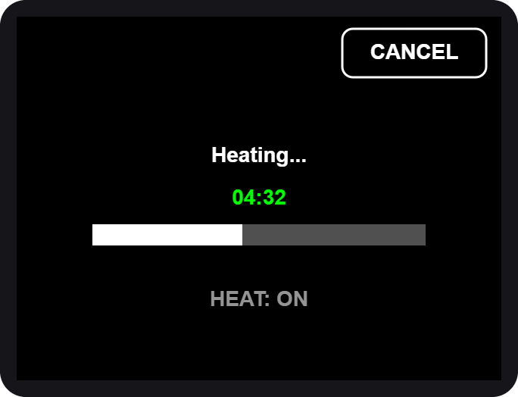  6. Heating... | 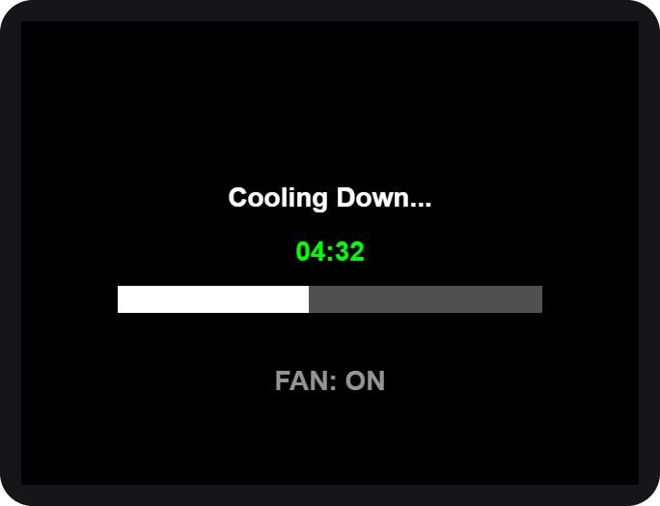  7. Cooling Down...

- Heating. Warm air dries the helmet and UV light freshens it. You can CANCEL, but coins are not refunded.
- Cooling down. A fan runs alone so the helmet is not hot to wear. The door stays locked until it ends.
- OPEN the door, TAKE your helmet, CLOSE the door.
- Rate it again, then use the free retry if you want one.

If you cancel while heating, the machine still cools the helmet down first, for your safety.

Box 3 - Cleaner + Dryer
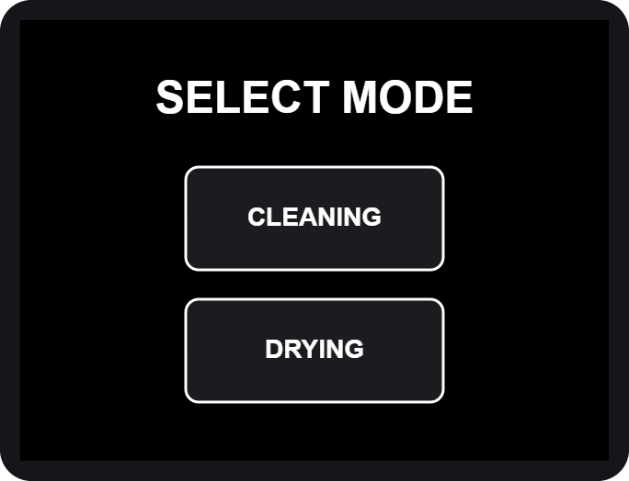  SELECT MODE | 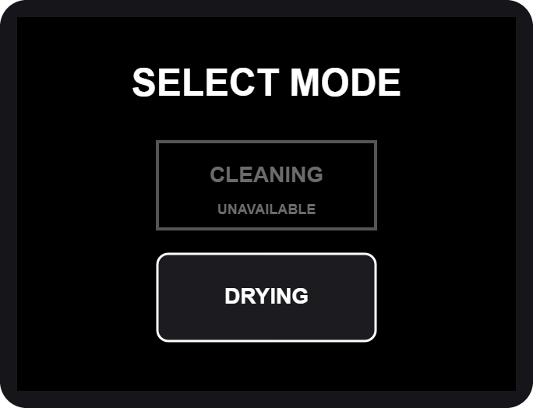  CLEANING unavailable

- Tap anywhere, then Tap to START.
- SELECT MODE. Tap CLEANING or DRYING.

If CLEANING is grey and says UNAVAILABLE, the cleaning liquids are being refilled or are low. DRYING still works.

CLEANING mode
Same steps as Box 1: rate the odor, choose the mist, pick the time, pay, load the helmet. At the end you rate two things: how dry it is, then how it smells. The heater runs only in the last minute, together with the UV light.

DRYING mode
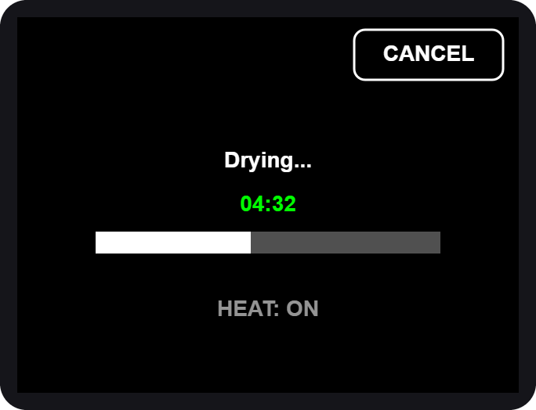  Drying... | 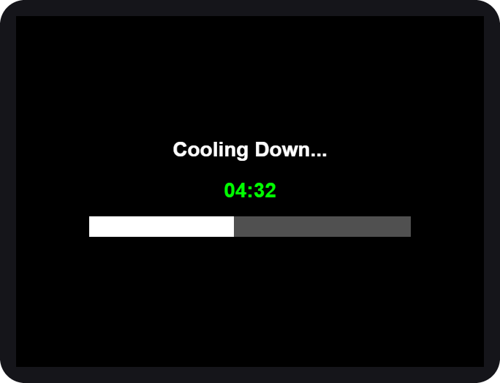  Cooling Down...

- Rate how wet the helmet is (DRY O' METER), then CONFIRM.
- Allocate drying time on the number pad.
- Pay, then OPEN, PLACE, CLOSE.
- Drying uses warm air and UV light. After it, the machine cools down for about a minute with nothing running.
- OPEN, TAKE, CLOSE, rate again and use the free retry if offered. A free retry after cleaning is another cleaning; after drying it is another drying.

Prices and time
Box 1 and Box 3 (cleaning): 15 coins = 5 minutes.

Rating | Suggested time | Coins
1 - 5 | 5 minutes | 15
6 - 7 | 10 minutes | 30
8 - 9 | 15 minutes | 45
10 | 20 minutes | 60

Longest session: 30 minutes (90 coins).
Box 2 (drying): 10 coins = 3 minutes.

Rating | Suggested time | Coins (about)
1 - 3 | 3 minutes | 10
4 - 6 | 5 minutes | 17
7 - 8 | 8 minutes | 27
9 - 10 | 10 minutes | 34

These are the starting prices. The admin can change them, so always check the INSERT THE REQUIRED COIN screen for the exact amount.

Special screens and safety

Special screens
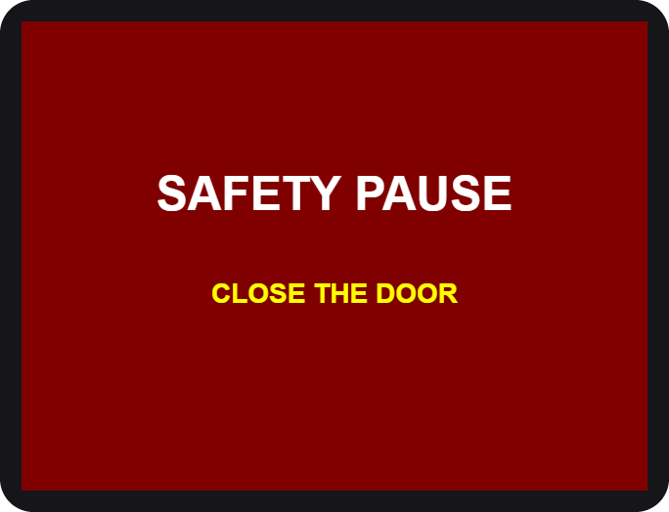  Door opened during a run |   Station needs service

You see | What it means / what to do
SAFETY PAUSE | The door was opened. Close it and the run continues.
HELMET NO DETECTED | No helmet seen. Open the door and place it again.
OUT OF ORDER | The station cannot work now. Use another station and tell the staff.
CLEANING UNAVAILABLE | Cleaning liquids are low. Use DRYING or come back later.
MAINTENANCE | A technician is working on the station.

Safety first
- Helmets only. Do not put bags, gloves, liquids or anything else inside.
- Keep your hands out while the machine runs. Hot air and UV light are used.
- UV light is strong. Never look into the chamber while it is on. The door must be closed.
- Do not force the door. It is locked on purpose while the machine runs. To stop, use CANCEL on the screen.
- Remove your helmet's accessories (camera, speaker, visor tint film) if they are not heat-safe.
- Children should use the machine with an adult.
- In an emergency, tap CANCEL, then CONFIRM. The machine stops and the door unlocks (on the dryers after a short cool-down).

If your helmet is stuck after a power cut or a fault, do not pull on the door. Tell the staff. The doors stay locked without power, and the staff can release the lock from the Control Center when power is back.

Questions

Question | Answer
The screen went white. | Wait a moment, it restarts itself. If it stays white, tell the staff.
I inserted a coin but nothing changed. | Insert the coin again slowly. Tell the staff if the count does not move.
Can I get a refund? | Coins are not refunded after the run has started or been cancelled.
The time is too long / too short. | On the number pad, type the time you want before tapping OK.
Why was I offered a free retry? | Because the helmet may need one more round. It is offered once per visit.
Which station should I use? | Smelly: Box 1 or Box 3 CLEANING. Wet: Box 2 or Box 3 DRYING.

Admin guide (Control Center)
The Control Center: settings, calibration and maintenance
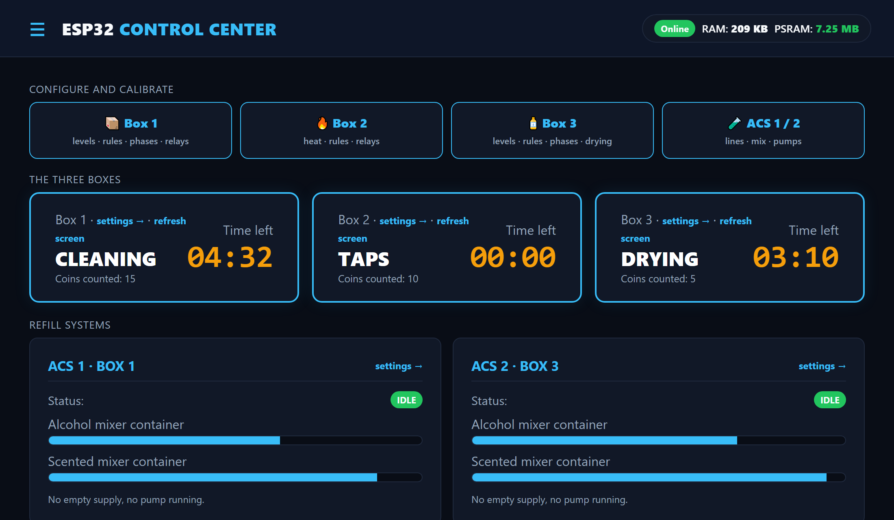
WEB PANEL FOR ADMINS AND TECHNICIANS

Connecting
The Control Center is a small web server (the LocalServer) inside the machine. You connect to it with a phone or laptop. It does not need internet.
- Switch on the machine and wait about 30 seconds.
- On your phone, join the Wi-Fi ESP32_LOCAL, password 12345678.
- Open a browser and go to http://192.168.4.1 (the page often opens by itself).
- The Home page appears. Use the menu button (three lines, top left) to open the settings pages.

The machines keep running and keep every setting even when the LocalServer is off or being replaced. It only shows, and sends your changes.

The Wi-Fi password is printed here for admins. Change it in the LocalServer program if this manual is shared outside the team.

Home page
- Alert banner (red): empty supplies, low mixers, a station out of order.
- Configure and calibrate: big buttons to Box 1, Box 2, Box 3 and ACS.
- The three boxes: current step, coins counted, time left, plus settings and refresh screen links.
- Refill systems: ACS status, mixer levels, empty or running pumps.
- Statistics: users served, revenue, average time, coins, last 10 cycles.
- Menu list: online/offline badge for every board.

Box settings (rules, levels, phases)

Rules and prices
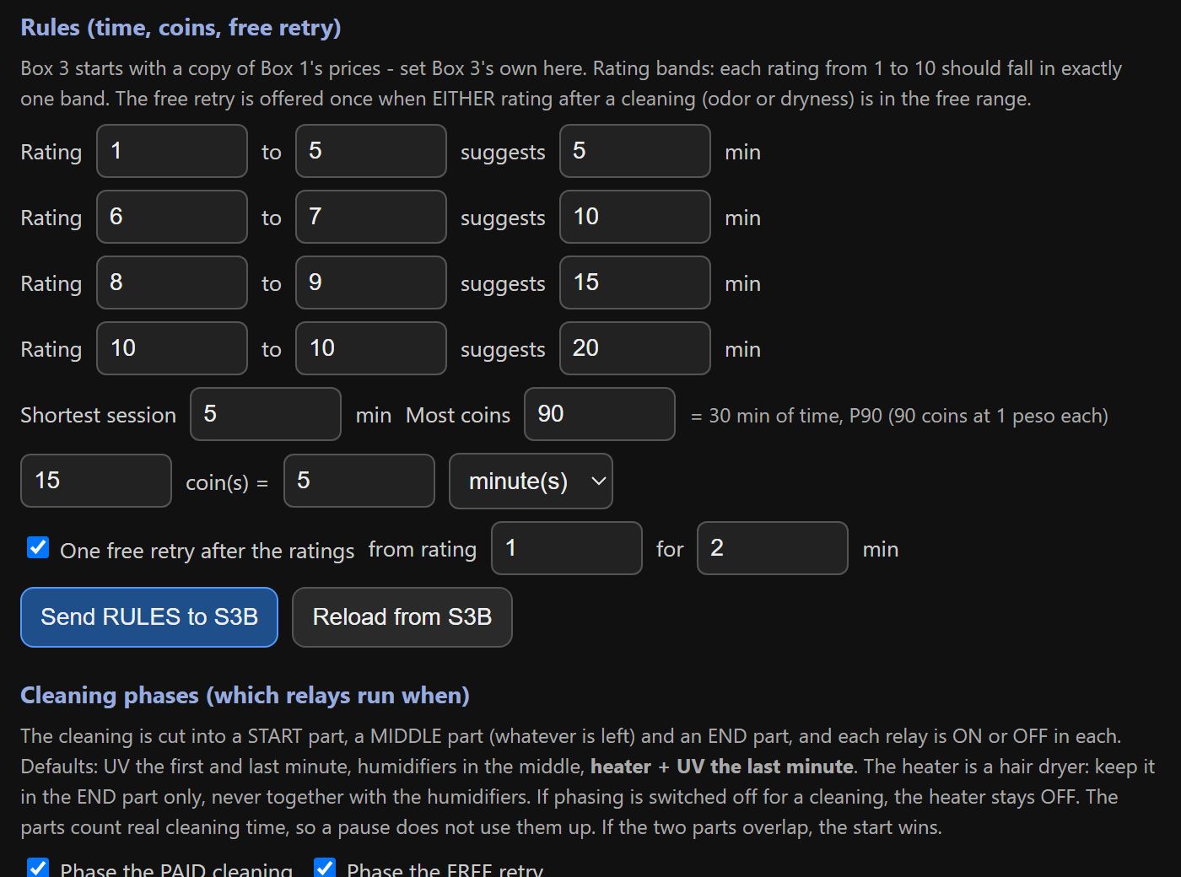
How to use it (Box 1, Box 2 and Box 3 have the same section):
- Open the box page, scroll to Rules.
- Set the rating bands (which ratings suggest how many minutes), the shortest session, the most coins and the coin rate (N coins = X minutes).
- Set the free retry (from which rating, for how many minutes).
- Tap Send RULES. A green tick means the box has saved them.

Containers and sensors
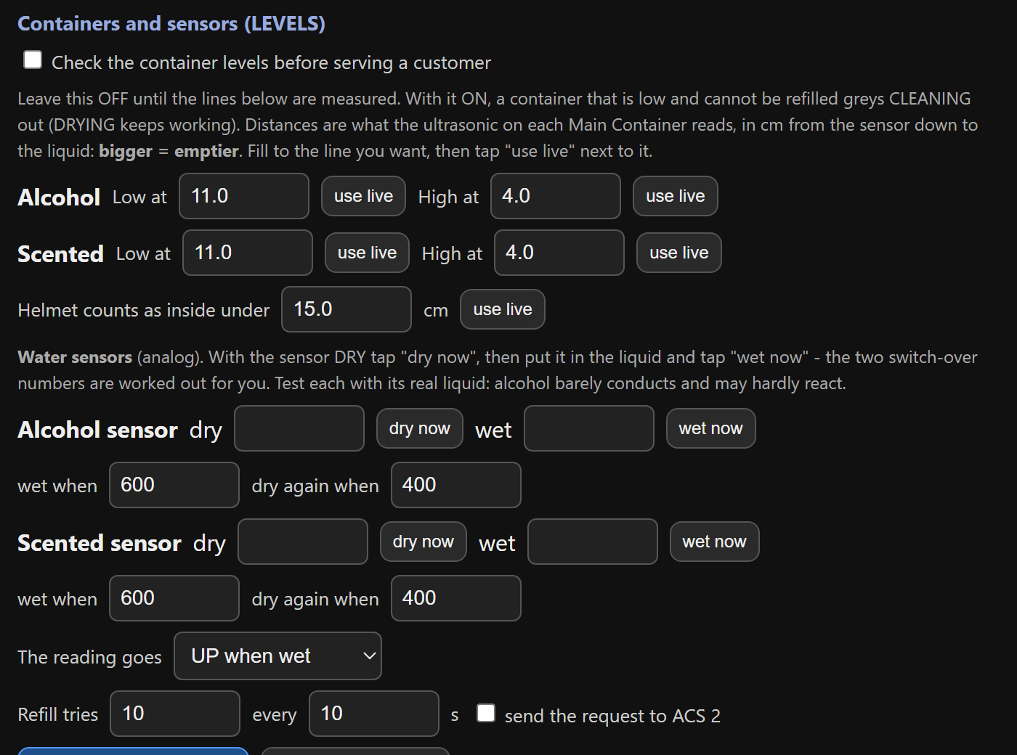
- Check the container levels: keep OFF until the numbers are measured.
- Low / High at: fill to the line, tap use live. Bigger number = emptier.
- Helmet inside under: put a helmet in, tap use live, raise it a little.
- Water sensors: dry now, then wet now in the real liquid (alcohol conducts poorly).
- Refill tries: tick send the request to the ACS only when the ACS works. Then tap Send LEVELS.

Cleaning phases
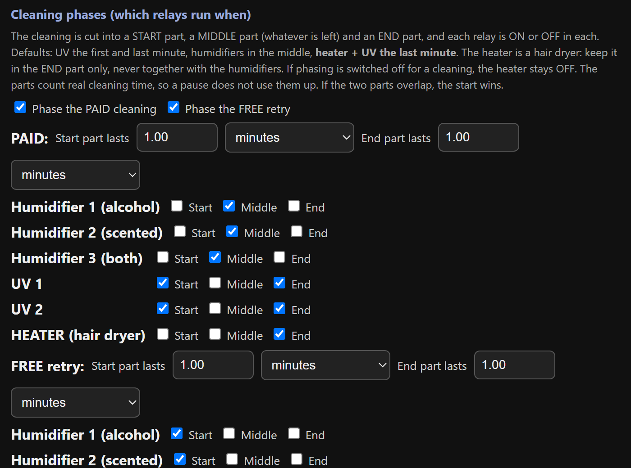
A cleaning is cut into a START part, a MIDDLE part and an END part. Tick when each relay is on.
- Example: UV on in Start and End, mist in the Middle.
- Always on = tick Start, Middle and End.
- Box 3: keep the HEATER in the End part only, never with a humidifier. The page warns you if they overlap.
- Paid cleaning and the free retry have their own tables.
Tap Send PHASES.

Heating and drying
- Box 2 - Heating: set the helmet distance (put a helmet in, use live) and the cool-down seconds (default 60, 5 to 900). Tap Send HEAT.
- Box 3 - Drying: set the cool-down seconds, then Send DRYING. The drying time itself comes from the customer's choice and the Rules.

Good to know
- Every setting is saved inside the box's own board, so it survives a power cut or a LocalServer replacement.
- If a number is outside its allowed range, the box refuses it. The green tick will not appear.
- Use Reload beside a Send button to bring back what the box really has.

Change one thing at a time and test it with a short session before leaving it.

Screen refresh and maintenance

Screen (touch display)
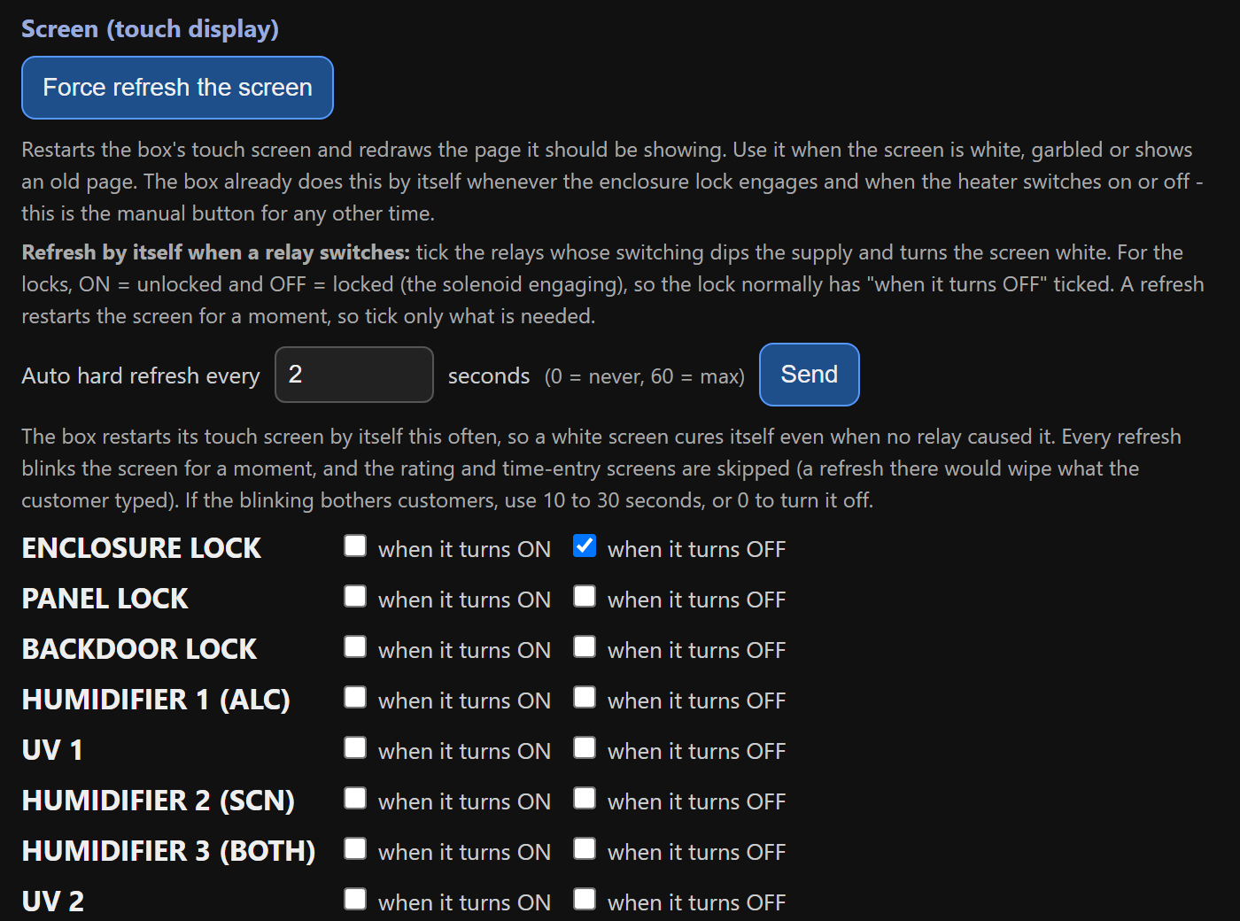
A heavy load switching on can make the touch screen go white. Three tools cure it:
- Force refresh the screen: restarts it now.
- Auto hard refresh every N seconds: restarts it by itself (0 = never, 60 = max). Rating and number-pad screens are skipped.
- Refresh when a relay switches: tick the relays (ON and/or OFF) that should trigger it. The lock is normally ticked OFF.

Maintenance mode
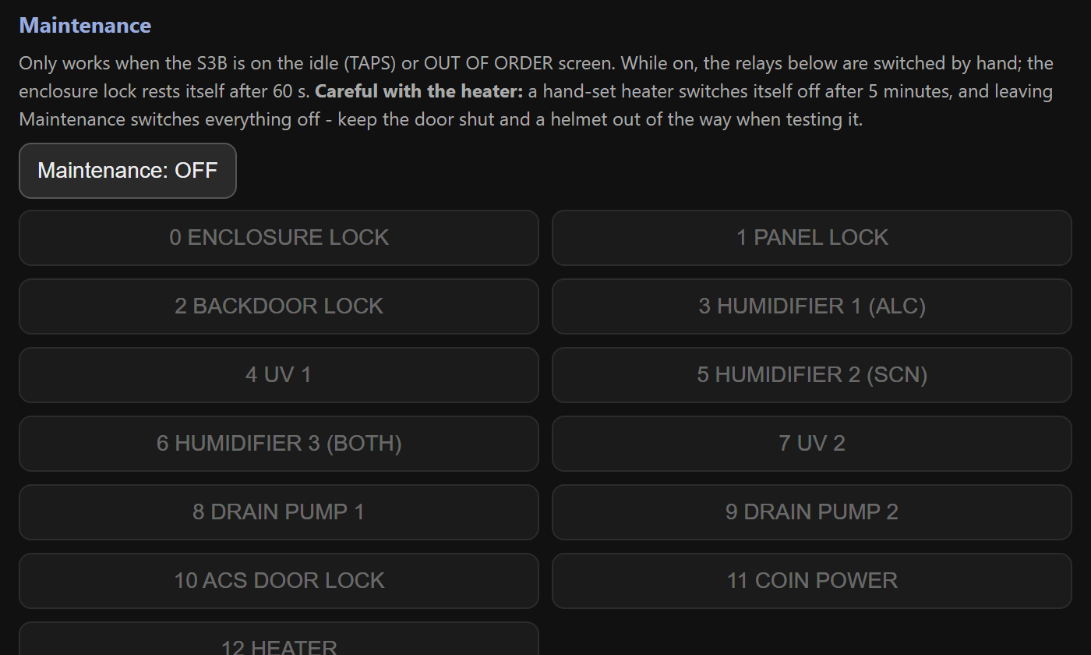
- Make sure the station is on its start screen (TAPS) or OUT OF ORDER.
- Tap Maintenance. The machine shows MAINTENANCE.
- Tap a relay button to switch it on or off by hand. Green = on.
- Tap Maintenance again. Everything switches off.

The hand-set heater turns itself off after 5 minutes and the lock after 60 seconds. Keep the door shut and clear when testing the heater.

Refill station (ACS)
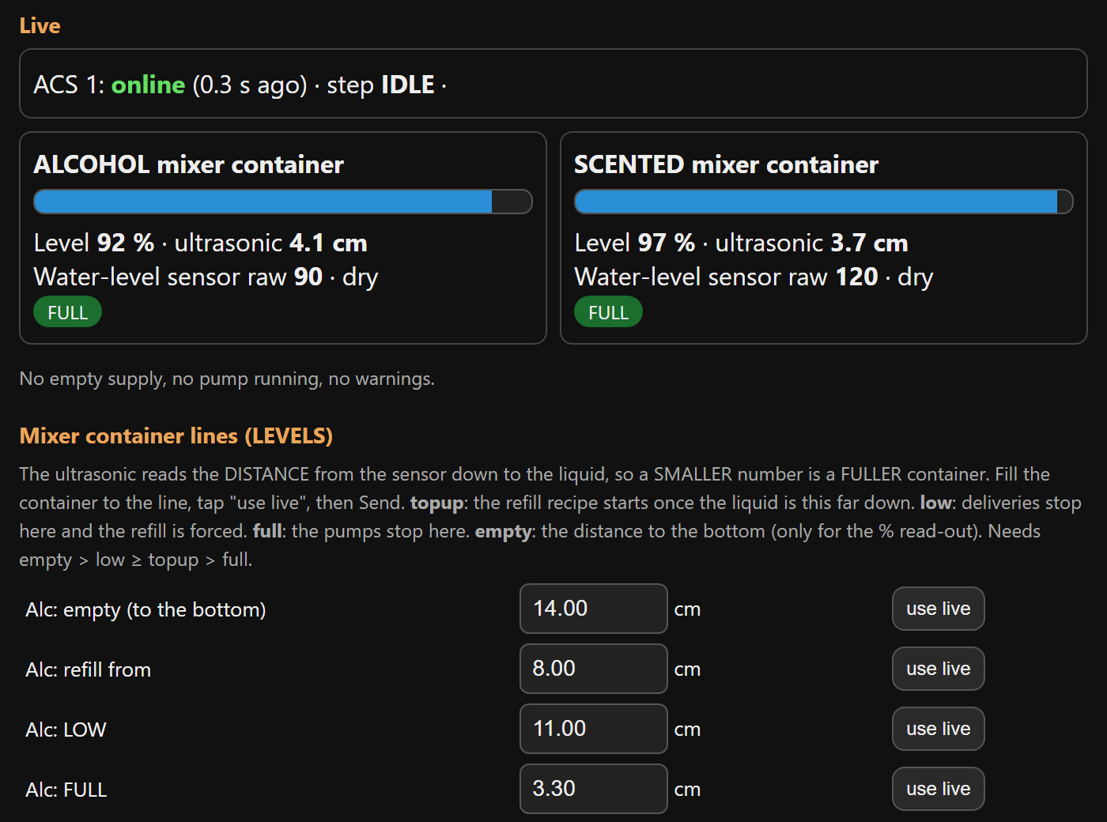
ACS 1 refills Box 1, ACS 2 refills Box 3. Each has three supply tanks (water, alcohol, scented), two mixer containers, and six pumps. Choose the ACS at the top of the page.
- When a mixer drops to its refill from line, the ACS adds water first, then the alcohol (or scented liquid) up to FULL.
- When a box asks, the matching mixer pump sends one short shot to the box.

Setting up the ACS
- Mixer container lines: fill each mixer to the line and tap use live for refill from, LOW, FULL and empty. Smaller number = fuller. Tap Send LEVELS.
- Mix: the water share of each top-up (30% water = 70/30 alcohol). Tap Send MIX.
- Timing / water-level sensors: use dry now / wet now for each sensor and Work out the thresholds. Tap Send TIMING.
- Check the pumps one at a time in Maintenance before the first automatic run.

Use plain water in all three supply tanks for the first test.

Reading the ACS

You see | It means
IDLE | Nothing to do. Mixers are above the refill line.
ALC WATER IN  ALC ALCOHOL IN | Filling the alcohol mixer: water, then alcohol.
SCT WATER IN  SCT SCENTED IN | Filling the scented mixer.
DELIVER ... | Sending one shot to the box.
WATER / ALCOHOL / SCENTED EMPTY | That supply tank is empty (or its pump is dead). The pump stopped and it retries in 5 minutes.
Half-made mix | A recipe was interrupted. The mixer is not delivered until it is finished.

Try it and fix it
- Ask: alcohol / scented pretends to be the box and makes one delivery shot. Stop cancels it.
- Retry now forgets an EMPTY verdict after you refilled a tank.
- Mixers are fine as they are clears the half-made flag when the mixers really hold good mix.
- Maintenance: run each of the six pumps by hand, one at a time. Each pump stops itself after 60 seconds.

Refilling a supply tank
- The three supply tanks have no sensors: look at them during your daily check.
- Refill the tank that is low or reported EMPTY.
- Tap Retry now.

Never run a pump dry. If liquid does not move when a pump runs, check the tube and the relay wiring first.

Troubleshooting and care

Troubleshooting

Problem | What to do
Screen white or garbled | Box page, Force refresh the screen. If it returns, tick the relay that causes it or lower the auto-refresh time.
A board shows OFFLINE | Check its power and wiring, then watch its badge on Home.
Station shows OUT OF ORDER | One board is silent (sensor or relay board). See the offline badges.
CLEANING is UNAVAILABLE | Containers are low. Check the ACS; refill, then Retry now.
Coins not counted | Use the coin check on the box page: pulses should rise by the coin's value.
Touch is off or upside down | The terminal needs its touch calibration or rotation checked.
Home says last restart BROWNOUT | Power dipped. Use a stronger supply and a short cable.

Care and spare parts

Daily check
- Home page: every badge ONLINE, no red banner.
- Look at the three ACS supply tanks (they have no sensors).
- Check the revenue and the number of users.

When a board breaks
- Keep one spare ESP32 per role, flashed and labelled (A1, S3B, ACS 2...).
- Swap it in and wire it exactly like the old one.
- Watch its badge turn ONLINE on Home, then re-enter that box's settings if they were lost.
- After rewiring, test each relay or pump by hand in Maintenance first.

S3A, S3B, S3C and the LocalServer are ESP32-S3 boards (16 MB, OPI PSRAM). The relay boards A3 and B3 must be plain ESP32 boards.

Technician guide (Hardware and maintenance)
Components, pinouts, wiring, firmware and maintenance

How it is built
Each machine is a small team of ESP32 boards that talk by radio (ESP-NOW, channel 1). The only wires between the boards are power wires.
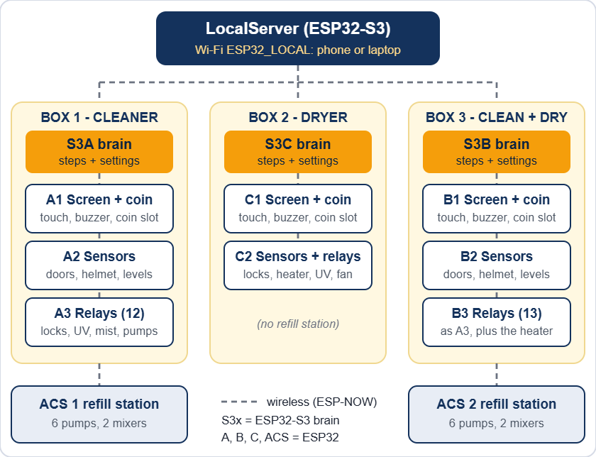
The whole installation: three boxes, two refill stations and the LocalServer

The 14 boards

Board | Where | What it does (sketch folder)
S3A | Box 1 | Brain. Runs every step and keeps the settings. (ESP32_S3A)
A1 | Box 1 | Touch screen, coin slot, buzzer. (ESP32_A1)
A2 | Box 1 | Sensors: 4 doors, helmet, 2 containers, 2 water sensors. (ESP32_A2)
A3 | Box 1 | 12 relays: 4 locks, 3 humidifiers, 2 UV, 2 drain pumps, coin power. (ESP32_A3)
S3C | Box 2 | Brain. (ESP32_S3C)
C1 | Box 2 | Touch screen, coin slot, buzzer. (ESP32_C1)
C2 | Box 2 | 3 door sensors, helmet sensor and 6 relays: 3 locks, heater, UV, fan. (ESP32_C2)
S3B | Box 3 | Brain. (ESP32_S3B)
B1 | Box 3 | Touch screen, coin slot, buzzer. (ESP32_B1)
B2 | Box 3 | Sensors, same as A2. (ESP32_B2)
B3 | Box 3 | 13 relays: same as A3 plus the heater. (ESP32_B3)
ACS 1 | Box 1 refill | 6 pumps, 2 mixer containers (ultrasonic and water sensor each). (ESP32_ACS1)
ACS 2 | Box 3 refill | Same as ACS 1. (ESP32_ACS2)
LocalServer | Control Center | Wi-Fi ESP32_LOCAL, settings pages, revenue. (ESP32_LOCALSRV)

Brains and terminals
- Brains (S3A, S3B, S3C, LocalServer) are ESP32-S3 boards with 16 MB flash and 8 MB PSRAM. Nothing is wired to them except power.
- Terminals (the A, B, C and ACS boards) are plain ESP32 (WROOM) boards on screw-terminal expansion boards. They hold every sensor, relay and display wire. A3 and B3 must not be WROVER (PSRAM) boards, because GPIO 16 and 17 are relays.
- Settings are saved inside the brains (S3A, S3B, S3C) and the ACS boards. The LocalServer only saves the revenue numbers.
- If a terminal hears nothing from its brain for 15 seconds, it switches its relays off (heater, UV, mist, pumps, coin power). If a helmet is stuck behind a closed door, it also lets the enclosure lock go.

Component list
Quantities are for the whole installation: Box 1, Box 2, Box 3, ACS 1 and ACS 2. A yellow confirm mark means: check this against your real part and edit it.

Boards and display

Item | Qty | Used in
ESP32 DevKit (ESP32-WROOM-32) with screw-terminal expansion board | 10 | A1 A2 A3 B1 B2 B3 C1 C2 ACS 1 ACS 2
ESP32-S3 DevKit N16R8 (16 MB flash, 8 MB OPI PSRAM) | 4 | S3A S3B S3C LocalServer
2.8 in SPI TFT with resistive touch (ST7789, 240 x 320) | 3 | A1, B1, C1
Allan multi-coin acceptor, 12 V | 3 | One per box
Active buzzer | 3 | A1, B1, C1
Resistor 10 kΩ | 3 | Coin signal lines

Sensors

Item | Qty | Used in
MC-38 magnetic door sensor (reed) | 11 | Box 1: 4, Box 2: 3, Box 3: 4
Ultrasonic distance sensor confirm model | 11 | Helmet: 3 (one per box). Main containers: 4. ACS mixers: 4.
Analog water-level sensor | 8 | Box 1: 2, Box 3: 2, ACS 1: 2, ACS 2: 2

Relay boards

Item | Qty | Used in
16-channel relay board, active-LOW | 2 | A3 (12 used), B3 (13 used)
6-channel relay module | 1 | C2 (all 6 used)
8-channel relay module with JD-VCC | 2 | ACS 1, ACS 2 (6 used each)

Loads

Item | Qty | Used in
12 V solenoid door lock | 11 | Box 1: 4 (enclosure, panel, back, ACS side). Box 2: 3. Box 3: 4.
Humidifier (mist maker), 5 V confirm | 6 | Box 1: 3, Box 3: 3 (alcohol, scented, both)
Drain pump, 5 V confirm | 4 | Box 1: 2, Box 3: 2
Refill pump, 5 V confirm | 12 | ACS 1: 6, ACS 2: 6
UV light, 12 V strip confirm | 5 | Box 1: 2, Box 2: 1, Box 3: 2
Heater (hair dryer), 220 V | 2 | Box 2, Box 3
Fan confirm voltage | 1 | Box 2 cool-down

Power and protection

Item | Qty | Used in
12 V power supply | confirm | Locks, UV, coin slots and the 5 V converters
DC-DC step-down, 12 V to 5 V | confirm | All ESP32 boards, screens, relay boards, sensors
Diode 1N4007 | 11 or more | One across every lock solenoid
Fuses, 220 V inlet or outlets, earth | confirm | Mains side, heaters

Not electrical: 2 main containers (alcohol, scented) in Box 1 and in Box 3. In each ACS: 3 supply tanks (water, alcohol, scented) and 2 mixer containers. Tubing and fittings.

What is in each unit

Item | Box 1 | Box 2 | Box 3 | ACS 1 | ACS 2
ESP32 terminal boards | 3 | 2 | 3 | 1 | 1
ESP32-S3 brain | 1 | 1 | 1 | - | -
Touch screen, coin slot, buzzer | 1 | 1 | 1 | - | -
Door sensors | 4 | 3 | 4 | - | -
Ultrasonic sensors | 3 | 1 | 3 | 2 | 2
Water-level sensors | 2 | - | 2 | 2 | 2
Door locks | 4 | 3 | 4 | - | -
Humidifiers | 3 | - | 3 | - | -
Drain pumps | 2 | - | 2 | - | -
Refill pumps | - | - | - | 6 | 6
UV lights | 2 | 1 | 2 | - | -
Heater | - | 1 | 1 | - | -
Fan | - | 1 | - | - | -

Pinouts
GPIO numbers are the ESP32 pin names (D4 = GPIO4). Every relay input is active-LOW: the pin goes LOW to switch the relay ON. These tables match the flashed firmware and the pin sheet RevisedJollyHelmet_Checked.xlsx.

Relay input numbers (IN1, IN2...) come from the Cirkit drawing. The GPIO is what the firmware drives. If a relay sits on a different input, trust the GPIO and fix the label.

S3A, S3B, S3C and LocalServer - nothing to wire
These four boards have no external wiring: power (5 V) and the USB cable for flashing only. GPIO 35, 36 and 37 are used inside the module by the OPI PSRAM: never connect anything to them.

A1, B1, C1 - screen, coin slot, buzzer
Identical wiring on all three boards:

GPIO | Signal | Wired to
15 | TFT CS | Display CS
4 | TFT RESET | Display RST
2 | TFT DC | Display DC (RS)
13 | MOSI (shared) | Display SDI (SDA) and touch T_DIN
14 | SCK (shared) | Display SCK (SCL) and touch T_CLK
27 | Touch CS | Touch T_CS
12 | Touch MISO | Touch T_DO
23 | Coin signal | Allan COIN, through a 10 kΩ resistor
21 | Buzzer | Active buzzer +
5V | Display power | Display VCC and LED (BLK) confirm VCC rail
GND | Ground | Display, coin acceptor, buzzer -

- Not connected: display SDO (MISO), touch T_IRQ, coin COUNTER.
- Coin acceptor 12 V: from the COIN POWER relay on A3 and B3 (Box 1, Box 3). Straight from the 12 V supply in Box 2.
- Free pins: 5, 16, 17, 18, 19, 22, 25, 26, 32, 33.

A2, B2 - sensors (Box 1, Box 3)

GPIO | Signal | Wired to
26 | Helmet ultrasonic TRIG | Sensor TRIG
25 | Helmet ultrasonic ECHO | Sensor ECHO
32 | Alcohol container TRIG | Sensor TRIG
33 | Alcohol container ECHO | Sensor ECHO
23 | Scented container TRIG | Sensor TRIG
22 | Scented container ECHO | Sensor ECHO
27 | Enclosure door | MC-38 sensor S
14 | Panel door | MC-38 sensor S
19 | Back door | MC-38 sensor S
18 | ACS side door | MC-38 sensor S
34 | Alcohol water sensor | SIG (analog, input only)
35 | Scented water sensor | SIG (analog, input only)

- Ultrasonic VCC 5 V. Water sensors 3.3 V. Door sensors: the other wire goes to GND, the ESP32 supplies the pull-up (closed = LOW).
- Free pins: 2, 4, 12, 13, 15, 16, 21.

A3 - Box 1 relays (16-channel board)

GPIO | Input | Load | Supply
4 | IN1 | Enclosure door lock | 12 V
16 | IN2 | Panel door lock | 12 V
17 | IN3 | Back door lock | 12 V
23 | IN4 | ACS side-door lock | 12 V
18 | IN5 | Humidifier 1 (alcohol) | 5 V
19 | IN6 | Humidifier 2 (scented) | 5 V
25 | IN7 | Humidifier 3 (both) | 5 V
22 | IN9 | Coin power (the coin slot's 12 V) | 12 V
27 | IN10 | UV 1 | 12 V
21 | IN11 | UV 2 | 12 V
33 | IN12 | Drain pump 1 (alcohol container) | 5 V
32 | IN13 | Drain pump 2 (scented container) | 5 V

- Supply column: from the pin-sheet totals (12 V x 7, 5 V x 5). confirm
- IN8 and IN14 to IN16 are not used. GPIO 2, 12 and 15 are left idle (boot pins).

B3 - Box 3 relays (16-channel board)
Pin for pin the same as A3, plus one more relay:

GPIO | Input | Load | Supply
26 | IN14 | Heater (hair dryer) | 220 V via the relay contacts

C2 - Box 2 sensors and relays

GPIO | Signal | Wired to
26 | Helmet ultrasonic TRIG | Sensor TRIG
25 | Helmet ultrasonic ECHO | Sensor ECHO
27 | Enclosure door | MC-38 sensor S
14 | Panel door | MC-38 sensor S
19 | Back door | MC-38 sensor S

Relays (6-channel module):

GPIO | Input | Load | Supply
4 | IN1 | Enclosure door lock | 12 V
16 | IN2 | Panel door lock | 12 V
17 | IN3 | Back door lock | 12 V
18 | IN4 | Heater (hair dryer) | 220 V
23 | IN5 | Fan | confirm
5 | IN6 | UV strip light | 12 V

- GPIO5 gives a short pulse when the board powers up, so the UV relay may click once. Harmless. Boot-safe spare pins: 13, 21, 22, 32, 33.

ACS 1 and ACS 2 - refill stations
Identical wiring on both. Relays (8-channel module with JD-VCC, 6 used):

GPIO | Input | Pump | Supply
18 | IN1 | Alcohol pump (tank to alcohol mixer) | 5 V
19 | IN2 | Scented pump (tank to scented mixer) | 5 V
21 | IN3 | Water pump for the alcohol mixer | 5 V
23 | IN4 | Water pump for the scented mixer | 5 V
22 | IN5 | Mixer alcohol pump (mixer to the box) | 5 V
25 | IN6 | Mixer scented pump (mixer to the box) | 5 V

Sensors:

GPIO | Signal | Wired to
4 | Alcohol mixer ultrasonic TRIG | Sensor TRIG
14 | Alcohol mixer ultrasonic ECHO | Sensor ECHO
26 | Scented mixer ultrasonic TRIG | Sensor TRIG
33 | Scented mixer ultrasonic ECHO | Sensor ECHO
34 | Alcohol mixer water sensor | SIG (analog)
35 | Scented mixer water sensor | SIG (analog)

- The three supply tanks (water, alcohol, scented) have no sensors. The ACS detects an empty tank when the mixer level does not rise.
- Pumps are 5 V confirm. Check each pump by hand in Maintenance before the first automatic run (the relay inputs were mixed up once).

Circuit and wiring

Circuit summary
- Every box and refill station is a group of ESP32 boards. They share only power and the radio channel.
- Every lock, lamp, pump and heater is switched by a relay contact. Every sensor is read directly by a terminal board.
- Voltages: 12 V (door locks, UV lights, coin slots), 5 V (ESP32 boards, screens, relay boards, ultrasonic sensors, humidifiers, pumps), 3.3 V (water-level sensors, from the ESP32 3V3 pin), 220 V (the heaters).

Power and grounding
- Measure every DC-DC converter with a meter before you connect boards. Never put 12 V on an ESP32 pin or on the 5 V rail.
- Join all grounds: 12 V -, 5 V - and every ESP32 GND. Never join a 12 V + to a 5 V +.
- A relay module has a JD-VCC jumper. Jumper on: the coils run from the module's VCC (one 5 V supply, shared ground). Jumper off: feed JD-VCC and its GND from a separate 5 V supply. confirm how each module is set
- Locks, pumps and heaters starting can pull the 5 V down. Symptoms: white screen, LocalServer restarts, odd resets. Cures: short thick 5 V wires, a 470 to 1000 µF capacitor next to the TFT and the ESP32, a separate 5 V for the relay coils. The firmware also switches relays on 25 ms apart.
- Put a fuse on every supply. Keep the 220 V wiring in its own enclosure, away from the boards.
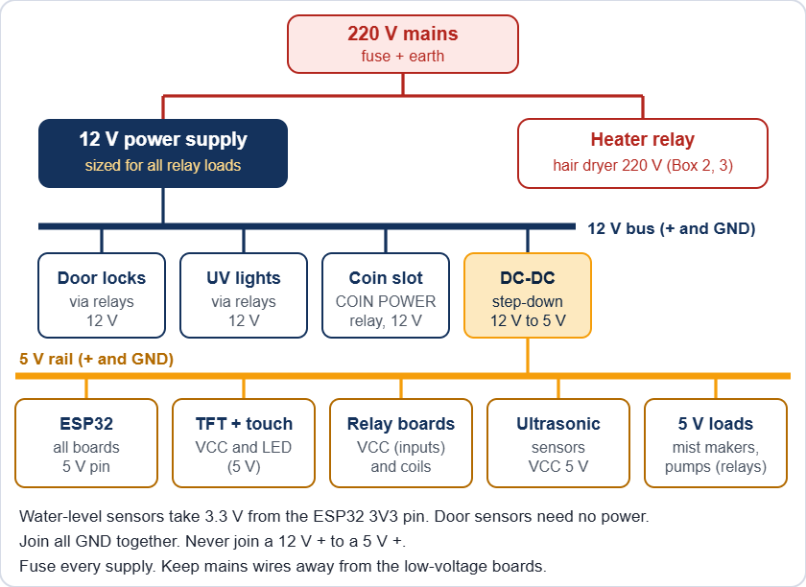
Power for one box (the exact rails are listed in the component tables)

Relay outputs
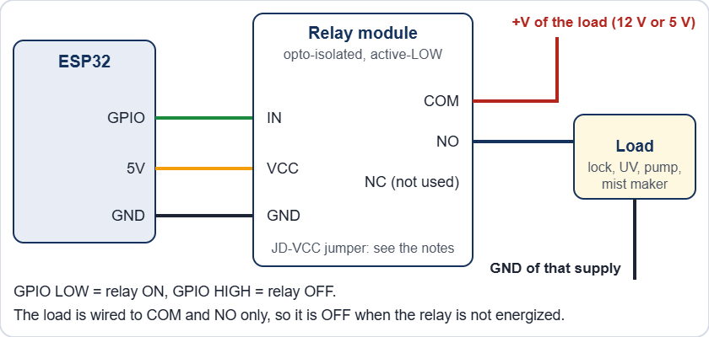
One relay channel
- Wire the load to COM and NO. Then it stays off when the relay or the board has no power. Leave unused channels unwired.
- Relay pins avoid GPIO 0, 1, 2, 3, 5, 12, 14, 15 because they pulse at boot. Safe output pins: 4, 13, 16 to 19, 21 to 23, 25 to 27, 32, 33.
- GPIO 34, 35, 36 and 39 are input only.

Door locks
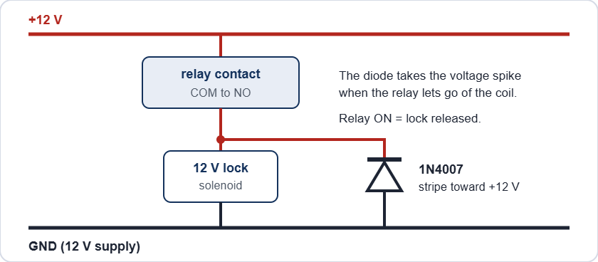
A door lock with its flyback diode
The locks are power-to-unlock: the relay is ON only while the door may open (the OPEN steps, Maintenance, or the trapped-helmet release). With no power the lock stays locked. The 1N4007 takes the voltage spike when the relay lets go of the coil. Without it the spike can reset the board and burn the relay contacts.

After a power cut the doors stay locked. When power is back, release the enclosure lock from the Control Center: Box page, Maintenance, ENCLOSURE LOCK. It switches itself off after 60 seconds.

Coin slot and buzzer
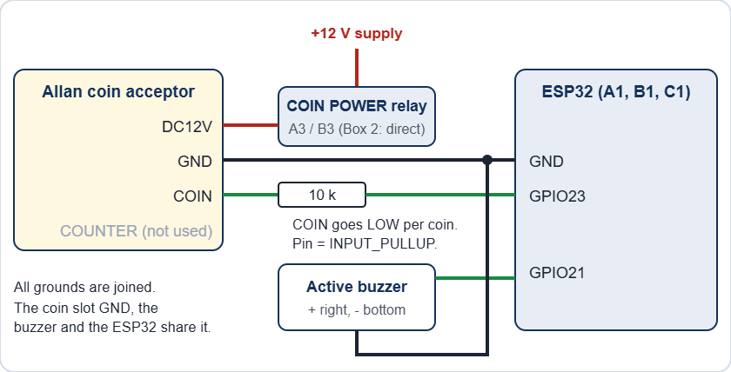
Coin acceptor and buzzer on A1, B1 and C1
- The Allan COIN output pulls to ground once per coin pulse. The pin is INPUT_PULLUP and the firmware counts falling edges, so the pin never sees more than 3.3 V. Check it once with a meter on every new unit.
- FAST, MED, SLOW and SET are switches on the acceptor itself, not wires. COUNTER is not used.
- The buzzer is the active type: GPIO21 HIGH = sound. If it sounds weak, or the board resets when it sounds, drive it through a transistor.

Sensors

Sensor | Wire | Goes to
Ultrasonic | VCC | 5 V
 | TRIG | GPIO (output)
 | ECHO | GPIO (input), through a divider if the module gives 5 V
 | GND | GND
Water-level | SIG | GPIO34 or GPIO35 (analog, input only)
 | VCC | 3.3 V
 | GND | GND
MC-38 door | S | GPIO (INPUT_PULLUP). Magnet near = closed = LOW
 | GND | GND

ECHO divider: ECHO to 1 kΩ to the GPIO, and 2 kΩ from that GPIO to GND. A 3.3 V module (HC-SR04P, RCWL-1601) needs none. The pin sheet shows no divider, so check which modules you have. confirm

Screen and touch
The display and the touch controller share the SPI lines MOSI (13) and SCK (14). Each has its own chip select (15 and 27). TFT_eSPI drives the display as an ST7789, 240 x 320. B1 is mounted upside down, so it runs setRotation(3).

Mains and UV safety

Mains can kill. Unplug the machine and wait before you open a box. Keep the heater wiring fused, earthed, in a closed enclosure with strain relief, away from the low-voltage boards.

UV light injures eyes and skin. The firmware switches UV and mist off the moment a door opens, but firmware is not a safety device. Recommended: a door switch in series with the UV supply, so the light cannot be on with the door open, and a warning label.

Firmware and flashing

Arduino IDE settings

Board type | Settings
Terminals (A, B, C, ACS) | Board: ESP32 Dev Module. esp32 core 3.3.7. Upload speed 921600. Other options default.
Brains (S3A, S3B, S3C) and LocalServer | Board: ESP32S3 Dev Module. USB CDC On Boot: Enabled. CPU 240 MHz. Flash mode QIO 80 MHz. Flash size 16 MB. Partition: 16M Flash (3MB APP/9.9MB FATFS). PSRAM: OPI PSRAM. Upload speed 921600.

Libraries
- TFT_eSPI 2.5.43: only A1, B1, C1 (edit its User_Setup.h, see below).
- ArduinoJson 7.4.3, Async TCP 3.5.0, ESP Async WebServer 3.12.0: only the LocalServer.
- Everything else (WiFi, ESP-NOW, Preferences) comes with the ESP32 core.

TFT_eSPI User_Setup.h

Setting | Value
Driver | ST7789_DRIVER (the only one not commented out)
TFT_WIDTH, TFT_HEIGHT | 240, 320
TFT_MISO, TFT_MOSI, TFT_SCLK | 12, 13, 14
TFT_CS, TFT_DC, TFT_RST | 15, 2, 4
TOUCH_CS | 27
SPI_FREQUENCY, SPI_TOUCH_FREQUENCY | 20000000, 1000000

Flash a new or replacement board
- Find the board in the table The 14 boards and open its sketch folder in the Arduino IDE.
- The folder must hold the same Shared_Common.h as ESP32_S3A (the master copy). Different copies make boards ignore each other's messages.
- Choose the settings above, plug in the USB cable and upload.
- Open the Serial Monitor at 115200 baud to read the board's log.
- Watch the board's badge turn ONLINE on the Control Center Home page.
- For a brain (S3) or an ACS board, enter its settings again on its Control Center page. A new board starts with the default values.

Never run a bench or settings sketch (ESP32_S3A_CONFIG_BENCH, ESP32_S3C_CONFIG_BENCH, ESP32_ACS_CONFIG_BENCH, ESP32_A1_WIDGET_TEST) at the same time as the LocalServer or the real brain. They send the same messages and fight over them.

Test sketches

Sketch | Use
ESP32_A3_BENCH_TEST | Tests A3 alone: it pretends to be S3A and A2.
ESP32_B3_RELAY_TEST | Wi-Fi page (BOX 3 B3 TEST, password 12345678) to switch each B3 relay by hand.
ESP32_BUZZER_ULTRASOUND_TEST | Wi-Fi page to test a buzzer and read an ultrasonic sensor.
ESP32_C1_CALIBRATE | Touch calibration: touch the 4 targets, copy the printed calData line into the terminal sketch.

Safety built into the firmware
- Every relay pin is set OFF before it becomes an output, so relays do not pulse at power-up.
- Relays that turn on are staggered 25 ms apart, so loads do not start in the same instant.
- A door that opens during a run switches UV and mist off at once (SAFETY PAUSE).
- A terminal that loses its brain for 15 seconds switches its relays off.
- Hand-set relays in Maintenance switch themselves off: heater after 5 minutes, locks after 60 seconds, ACS pumps after 60 seconds.
- The coin slot only has power while a payment is possible (Box 1 and Box 3).

Maintenance

Before you open a box: finish or cancel any run, switch the machine off at the mains and unplug it. Wait for the heater to cool.

Schedule

When | What to do
Every day | Home page: every badge ONLINE and no red banner. Look at the 3 supply tanks in each ACS and the 2 main containers. Wipe the touch screens. Collect the coins and note the revenue.
Every week | Wipe the helmet chamber and the door seals. Open each door during a run: SAFETY PAUSE must show. Listen for each lock clicking. Look for leaks at pump tubes and mixers. Check the UV lights glow and the humidifiers make mist.
Every month | Switch every relay by hand in Maintenance and listen for the click. Clean the ultrasonic sensor faces and the water-level probes. Compare each distance with a ruler (use live). Test the coin slot with every coin. Check screw terminals and plugs are tight and nothing is hot or discoloured. Clean the humidifier discs and the heater and fan air intakes.
Every 3 months | Capture the water sensors again, dry and wet, with the real liquids. Check the touch accuracy. With the power off, check the mains wiring, earth and fuses. Take a screenshot of every Control Center settings page and keep it.
Once a year or when worn | Replace UV lights at the end of their rated hours. Replace pump tubing and slow pumps. Replace any lock that sticks or gets hot. Replace humidifier discs.

Calibrate

What | How (Control Center)
Helmet distance | Box page: put a helmet in, tap use live, then Send. Do the same on Box 2 (HEAT).
Container lines | LEVELS: fill to each line, tap use live. Bigger number = emptier.
Water sensors | LEVELS: dry now, then wet now in the real liquid (alcohol conducts poorly).
ACS mixer lines and sensors | ACS page: LEVELS and TIMING, use live and Work out the thresholds.
Coin slot | Check the coin pulses on the box page: they must rise by the coin's value. Speed (FAST, MED, SLOW) is set on the acceptor.
Touch screen | Flash ESP32_C1_CALIBRATE on the terminal, touch the 4 targets, copy the calData line into the terminal sketch and flash it again. B1 (Box 3) may still need this.

Test every output by hand
- Put the box on its start screen (TAPS) or OUT OF ORDER.
- Control Center, box page, Maintenance. Tap each relay and check that the right thing happens.
- Do the ACS pumps one at a time and compare each with its label before you trust the automatic run.
- Tap Maintenance again. Everything switches off.

Replace a broken board
- Power off. Photograph the wiring, or print the pin table of that board.
- Move the wires one at a time to the same GPIO on the new board.
- Flash the right sketch (see Firmware and flashing). A3 and B3 must be plain ESP32 boards.
- Power on and wait for the ONLINE badge, then test each output by hand.
- Brain (S3) or ACS replaced: enter its settings again. LocalServer replaced: the revenue numbers start from zero.

Spare parts to keep
- One spare ESP32 per role, flashed and labelled: A1, A2, A3, C1, C2, B1, B2, B3, ACS, plus one ESP32-S3.
- One spare relay board of each size, 2 MC-38 sensors, 2 ultrasonic sensors, 2 water-level sensors.
- One door lock solenoid, one 12 V supply, 2 DC-DC converters, fuses.
- Spare pumps and tubing, one UV light, one humidifier, a 10 pack of 1N4007 and 10 kΩ, a few 470 to 1000 µF capacitors.

Hardware troubleshooting

Symptom | Likely cause | What to do
Screen goes white when a lock or pump switches | The 5 V dips | Force refresh or Auto hard refresh (Control Center). Add a 470 to 1000 µF capacitor at the TFT supply. Shorter, thicker 5 V wires.
A relay clicks once at power-up | A pin that pulses at boot (GPIO5 on C2) | Harmless. Move it to a boot-safe pin if it bothers you.
A relay stays ON with no command | A boot-active pin, or a wire on the wrong input | Use a boot-safe pin (GPIO13 was moved to 33 on A3 and B3). Check the wiring.
LocalServer restarts when a phone connects | Supply dip (Home page says BROWNOUT) | Own 5 V supply, short cable, a 470 to 1000 µF capacitor.
A board shows OFFLINE | No power, the wrong sketch, or a bench sketch running | Measure 5 V at the board. Flash the right folder. Switch off every bench sketch. All boards use ESP-NOW channel 1.
Door always open or always closed | Magnet too far, or a wrong wire | Check the gap (a few mm) and the wire from S to the GPIO. Closed must read LOW.
Ultrasonic reads 0 or jumps | No echo, dirty face, TRIG and ECHO swapped, loose wire | Clean the face, check both wires, read the board's log.
Water sensor always wet or always dry | Dirty probes, or a bad dry/wet capture | Clean the probes. Capture dry and wet again in the real liquid.
Coins not counted | Coin slot has no power, loose COIN wire, wrong speed setting | The slot is powered only in the pay steps. Measure its 12 V at DC12V then. Check the 10 kΩ and the COIN wire.
A pump runs but the wrong liquid moves | Relay wired to the wrong pump | Run each pump by hand in Maintenance and fix the wiring.
A lock does not release | No 12 V at the solenoid, or the door presses on the latch | Measure the solenoid while its relay is ON. Push the door in a little.
A lock is hot | It was powered too long | Check for a stuck relay. The firmware limits how long a lock stays energized.
Helmet stuck after a power cut | Locks are power-to-unlock | When power is back, use Maintenance, ENCLOSURE LOCK.

Thank you for using
Jolly Helmet
We hope to see you again!
Make your Helmet Happy Again.
MEJEZ STUDIO
[School / contact details here]
[Email or phone number here]
USER MANUAL

